Market Monitor - Bangladesh - 2026-06

Highlights
The market outlook for Bangladesh is marked by uncertainty, with localized supply chain disruptions from flooding in the Sylhet district and a forecast El Niño event posing significant risks to food security. A lack of quantitative data for the current period prevents a detailed assessment of price movements.
The cost of the national food basket could not be calculated for June 2026 due to the unavailability of price data.
Data for individual commodity price changes was not available for this reporting period.
Key Drivers
- Key market drivers could not be determined due to the absence of quantitative data for the reporting period.
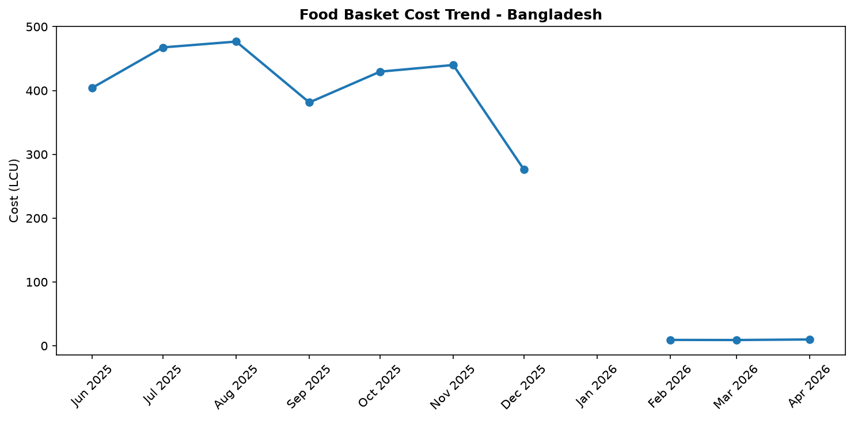
Food basket cost trend

Market Overview
The market in Bangladesh exhibited a volatile trajectory in June 2026, characterized by significant uncertainty and localized disruptions rather than a clear nationwide trend. A lack of quantitative price data for this period prevents a definitive analysis of market drivers; however, contextual factors point towards an environment of heightened risk. Immediate market stability is being challenged by severe, region-specific shocks. In the Sylhet district, major floods have disrupted supply chains and prompted an anticipatory response from the World Food Programme, signaling a severe impact on local food access and availability. Concurrently, rising tensions over food security policies for Rohingya refugees are creating potential for supply and demand imbalances in host community markets. Looking forward, the forecast persistence of an El Niño event through 2026 and into early 2027 poses a substantial threat to future agricultural cycles and national food security. These combined factors—immediate logistical crises and a looming climatic threat—suggest a high potential for upward price pressure and instability, particularly in the most affected regions. The overall outlook remains precarious, contingent on the mitigation of these localized and national-level risks.

Commodity Analysis
A specific quantitative analysis of commodity price trends is not possible for this reporting period due to the absence of food basket and price data. However, an assessment of recent events indicates significant potential pressure on the prices of key food items. The most immediate factor is the severe flooding in the Sylhet district. This event has likely damaged standing crops and stored grains, while simultaneously crippling transportation networks. Consequently, the availability of perishable goods like vegetables and staple foods such as rice is expected to be constrained within the region, creating localized price spikes. On a national scale, the developing El Niño phenomenon represents a major medium-term threat to agricultural commodities. Altered rainfall patterns and higher temperatures associated with El Niño could adversely affect the productivity of critical rice harvests (Aman and Boro) and other staple crops, jeopardizing national supply and price stability in the coming year. Furthermore, tensions surrounding the food ration policy for Rohingya refugees could influence market dynamics in host communities. Any disruption to aid supply chains or shifts in refugee purchasing power could alter demand for essential commodities like rice, lentils, and cooking oil in local markets, introducing another layer of price volatility in those specific areas.
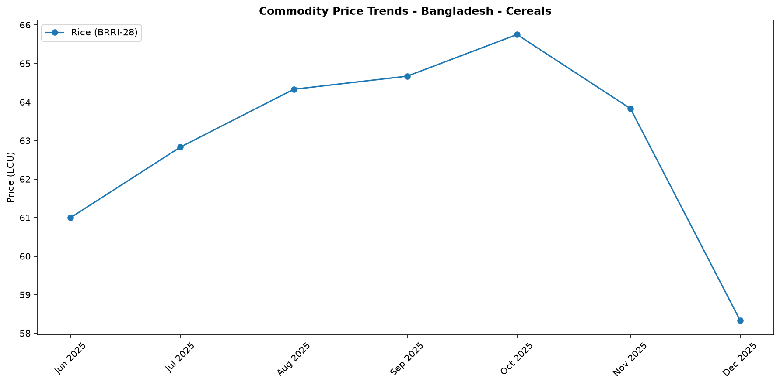
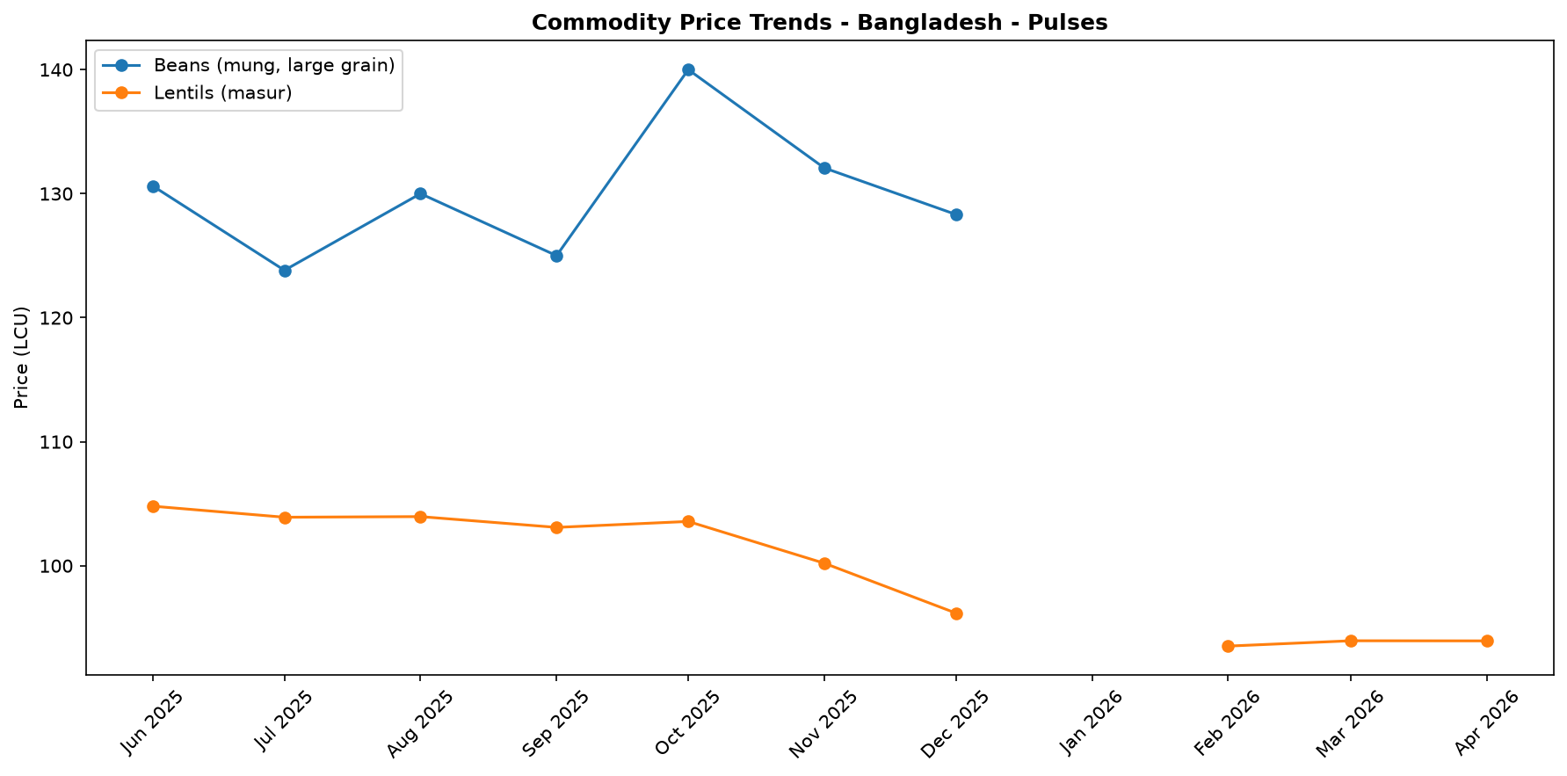
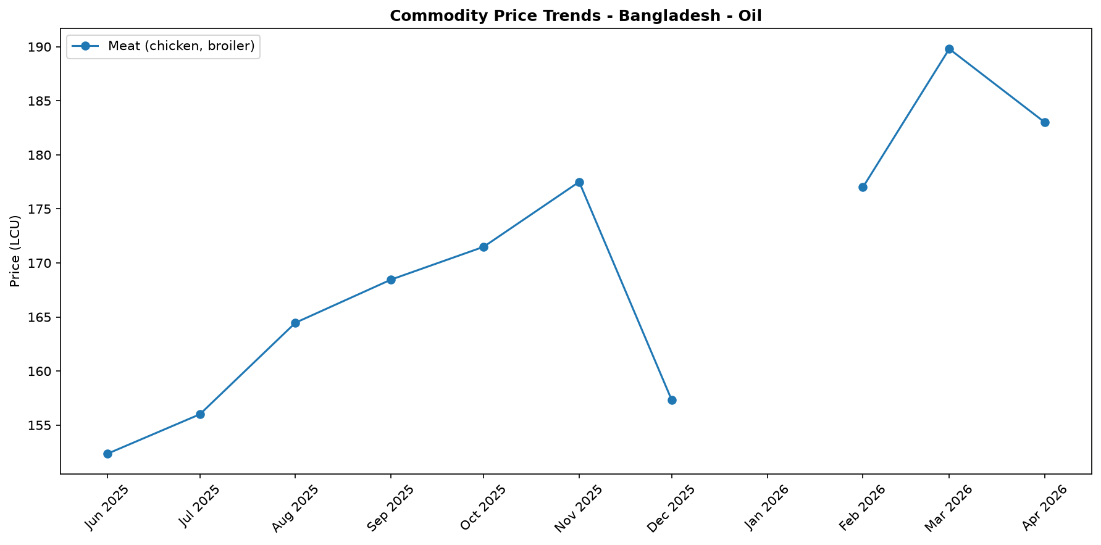
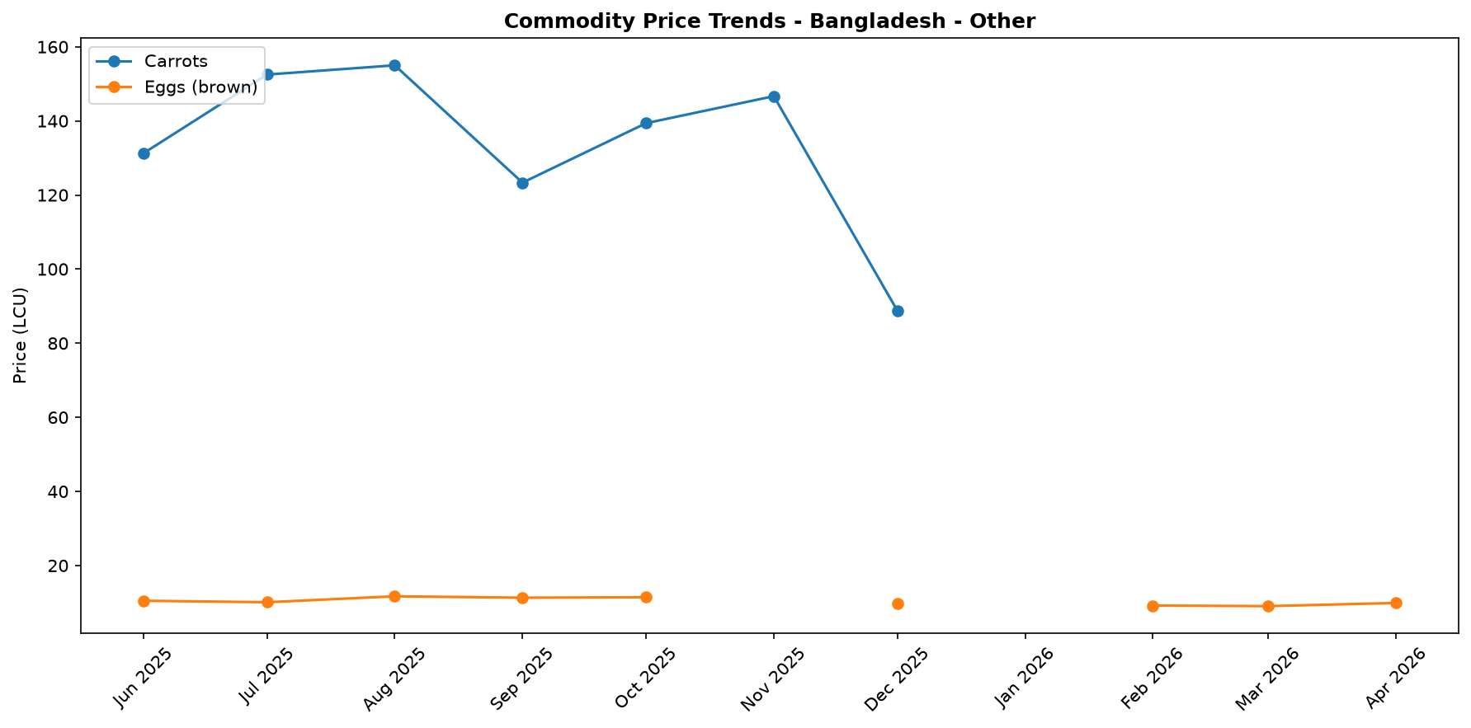

Regional Highlights
Regional market dynamics in June 2026 were dominated by acute, localized shocks, leading to significant divergence from any national baseline. The most severe disruption occurred in the Sylhet district, where extensive flooding crippled logistical operations and supply chains. The activation of an anticipatory action framework by the World Food Programme (WFP) underscores the severity of the situation, which is expected to severely impact food availability and access for the local population. This climate-driven crisis has likely resulted in significant, localized price volatility for essential goods.
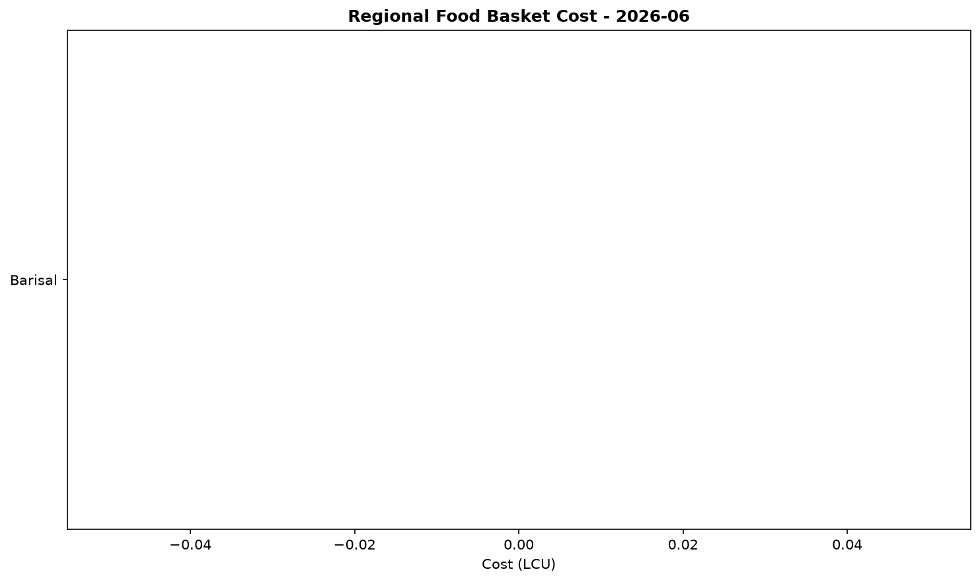
In parallel, regions hosting Rohingya refugees are experiencing mounting pressure of a different nature. Tensions over food security and ration policies are creating uncertainty in local markets, with the potential to disrupt supply and demand for staple food items. While the impact of the Sylhet floods is acute and logistical, the situation in refugee-hosting areas represents a chronic stressor with the potential to flare into localized market instability. These two distinct regional pressures highlight the fragile and fragmented state of market conditions across Bangladesh.

References
- [rw_4216543] ReliefWeb (2026-06-17) Asia and the Pacific: Snapshot of El Niño & Middle East Crisis (as of 12 June 2026)
https://reliefweb.int/node/4216543
- [rw_4216315] ReliefWeb (2026-06-15) UNFPA welcomes Bangladesh landmark commitment to deploy 25,000 midwives as world faces one-million midwife shortage
https://reliefweb.int/node/4216315
- [rw_4216224] ReliefWeb (2026-06-15) Asia-Pacific Gender Based Violence in Emergencies Update – Q2 2026 (Special Release for El Niño)
https://reliefweb.int/node/4216224
- [rw_4215341] ReliefWeb (2026-06-09) UNFPA Bangladesh Situation Report | Protracted Humanitarian Crisis in Bangladesh, 1 January - 31 March 2026
https://reliefweb.int/node/4215341
- [rw_4214267] ReliefWeb (2026-06-01) WFP Bangladesh Country Brief, May 2026
https://reliefweb.int/node/4214267
- [rw_4214182] ReliefWeb (2026-05-31) Finland boosts support for Rohingya refugees with EUR 2 million contribution [EN/BN]
https://reliefweb.int/node/4214182
- [rw_4214118] ReliefWeb (2026-05-29) Period poverty: A global menstrual health crisis
https://reliefweb.int/node/4214118
- [rw_4213869] ReliefWeb (2026-05-28) Asia and the Pacific: Weekly Regional Humanitarian Snapshot (19 - 25 May 2026)
https://reliefweb.int/node/4213869
- [rw_4213682] ReliefWeb (2026-05-26) Homestead Gardening Guidelines - Vegetable production for household consumption using minimal space in Rohingya camps and host communities
https://reliefweb.int/node/4213682
- [rw_4212820] ReliefWeb (2026-05-20) UN and partners appeal for USD 710.5 million to meet the critical needs of Rohingya refugees and Bangladeshi host communities [EN/BN]
https://reliefweb.int/node/4212820
- [seerist_1028985] Seerist (2026-06-15) Weak budget implementation, low revenues likely to limit reform, growth prospects
- [seerist_1028888] Seerist (2026-06-05) Big Picture series: Proposed tariffs on 60 economies portend creation of durable country-specific tariff regime
- [seerist_1028869] Seerist (2026-06-05) Big Picture series: The BNP at 100 days – a stuttering start on a long road ahead
- [seerist_1028666] Seerist (2026-05-22) Tiger kidnaps to remain rare despite incident involving bank manager in Dhaka district
- [seerist_1028464] Seerist (2026-05-08) Big Picture series: Keep calm and kharif on – fertiliser shock and political risk in South Asia

